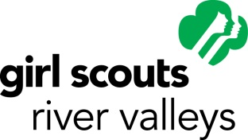
BOARD OF DIRECTORS/BOARD DEVELOPMENT COMMITTEE/BOARD COMMITTEE CANDIDATE REFERRAL FORM
Date: Position: Board BDC Committee:
Name of Candidate
Preferred Address ( home work)
City/State/Zip Code Phone ( day evening)
Preferred E-mail Address
Occupation/Job Title
Employer/Business Name
Nature of Occupation & Business

Demographics/Diversity
Racial Diversity:
Native American Asian/Pacific Islander African American Caucasian
Multi-Racial Hispanic Other/Unknown:
Age and Gender:
Female Male 14-17 18-29 30-39 40-49 50-59 60+
Geographic Location (Legacy Council Area):
Cannon Valley Greater Minneapolis Peacepipe River Trails St. Croix Valley

Skills/Experience
Leadership (business and/or community) Administrative Personnel
Legal Marketing Public Relations
Strategic Thinking/Planning Non-Profit Leadership/Mgmt. Board Experience
Program/Product Development/Mgmt. Personnel Fund Raising
Organizational Development/Mgmt. Teaching/Training Finance
Other:
Briefly describe candidate’s three greatest strengths that you believe qualify her/him for this position:
1.

2.

3.

If applicable, please describe this candidate’s Girl Scout experience/participation, both current and past.

Please describe this candidate’s sphere of influence. Local State National
Please Explain:

Does this candidate know his or her name has been put forward for consideration? Yes No
Referred by (Please Print Name):
Preferred Address ( home work)
City/State/Zip Code Phone ( day evening)
Preferred E-mail Address
Your position in Girl Scouting, if applicable:
Please return completed form by mail or email to:
Kathleen Meyerle, Chair
Board Development Committee
Girl Scouts of Minnesota and Wisconsin River Valleys
400 Robert Street South
St. Paul, MN
RVboard@girlscoutsrv.org

